Task for small RNA analyses

- Identify unique sets of gene enriched in only one WAGOs (IPs). Also identify shared sets of gene enriched in two Argonautes and highlight those with significant overlapping genes.
(for example, what genes are uniquely targeted by WAGO-1 but not any other Argonautes? What genes are both targeted by WAGO-1 and HRDE-1, and are these numbers indicate two Argonaute share more targets than expected?)

22G, antisense, IP enriched dataset1
List of WAGOs: WAGO-1 (D188, 3776), PPW-2, PPW-1, HRDE-1 (D296, 909), VASR-1, CSR-1, SAGO-1, SAGO-2, WAGO-4, NRDE-3, WAGO-10

Dnew=WAGO-1 unique target (D188-D296-xxxxx)

- Examine the relationship between IP unique gene list identified and those depleted in corresponding WAGO

(for example, how many genes are uniquely targeted by WAGO-1 and its small RNAs are depleted in wago-1 mutant?)

WAGO-1 mutant depleted (D192, 814)
交集 D188, D192 算overlap顯著性 低 p-value大
交集 Dnew, D192 算overlap顯著性 高 p-value 小

如何計算兩個ago target list交集程度的顯著性?
Total transcript=T=50000
First Ago target list = L1=3000
Second Ago target list = L2 = 2000
交集I =L1 & L2 =150
交集顯著性p-value 用hypergeometric test

https://stattrek.com/online-calculator/hypergeometric

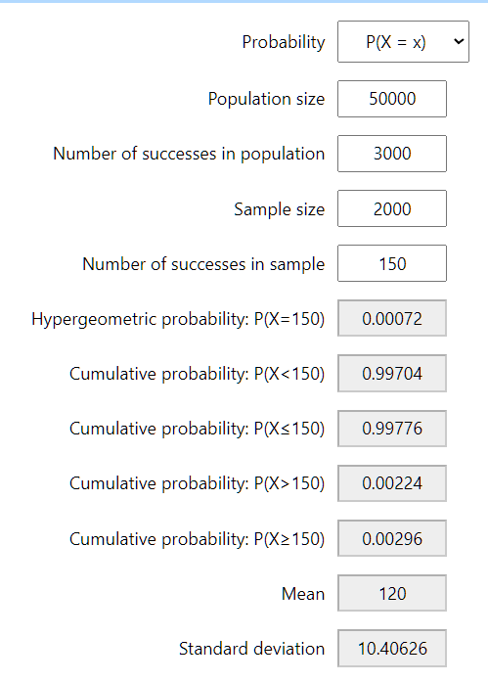

Few things to update on the database

Input a gene or transcript:
(reads antisense to Argonaute-bound small RNAs)

Input a small RNA:
(reads sense to Argonaute-bound small RNA)

- Examples:
Use xol-1 for an example of transcript

Use lin-4 for an example of miRNA
Use 21ur-4863 for an example of miRNA

- Target and browse
Example 1: Identify miRNAs that are both enriched in ALG-1 and ALG-2 IP samples.

Example 2: Identify small RNAs that are both depleted in prg-1 mutant and are enriched in HRDE-1 IPs

Label the origin of IP Enriched and mutant depleted data.
Dataset 1: Seroussi et. al., eLife, 2023
Dataset : Liu et al., Sci China Life Sci, 2023
Mutant depleted data: Seroussi et. al., eLife, 2023

Task for small RNA analyses

- Identify the gene sets that are both depleted in prg-1 mutant (or ergo-1, rde-1, csr-1 mutants) as well as those enriched in different WAGO IP.

- Identify the gene sets that are both enriched in ALG-3, ALG-4, RDE-1, ERGO-1 IP enriched samples and those enriched in different WAGO IPs

撈滿足條件的ago target lists

怎麼決定一個ago的targets?
A: IP enriched 1
B: IP enriched 2
C: mutant depleted

[all reads, 22G reads, 26G reads] x [sense, antisense] x [A, B, C, AB, AC, BC, ABC]

19個ago
選兩類
- 一定要是那些ago的targets
- 一定不能是那些ago的targets
沒選的ago就是don’t care

